**DAILY ONLINE ACTIVITIES SUMMARY**

|  |  |  |  |  |  |  |  |  |
| --- | --- | --- | --- | --- | --- | --- | --- | --- |
| **Date:** | **13-06-2020** | | | | | **Name:** | **Huda Sultana** | |
| **Sem & Sec** | **8 A** | | | | | **USN:** | **4AL16CS039** | |
| **Online Test Summary** | | | | | | | | |
| **Subject** | | **IOT** | | | | | | |
| **Max. Marks** | | **30** | | **Score** | | | **29** | |
| **Certification Course Summary** | | | | | | | | |
| **Course** | **Introduction to Amazon API Gateway** | | | | | | | |
| **Certificate Provider** | | | **AWS** | | **Duration** | | | **10mins** |
| **Coding Challenges** | | | | | | | | |
| **Problem Statement:**   1. Write a C Program to calculate Electricity Bill. | | | | | | | | |
| **Status: Solved** | | | | | | | | |
| **Uploaded the report in Github** | | | | | **Yes** | | | |
| **If yes Repository name** | | | | | **Hudasulltana/online_coding** | | | |
| **Uploaded the report in slack** | | | | | **Yes** | | | |

Online Test Details:

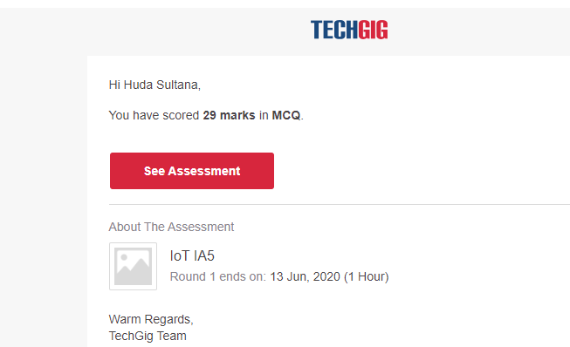

Certification Course Details:

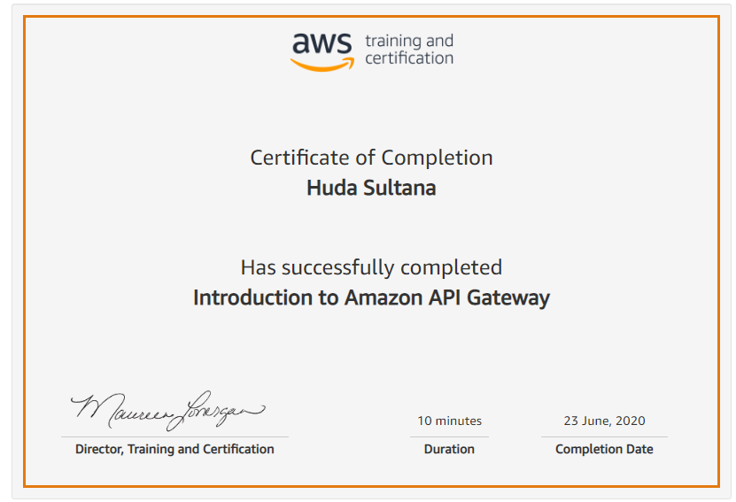

Coding Challenges Details: (Attach the snapshot and briefly write the report for the same)

**PROGRAM 1 .**

**//Write a C Program to calculate Electricity Bill**

**#include <stdio.h>**

**int main()**

**{**

**int unit;**

**float amt, total_amt;**

**printf("Enter total units consumed: ");**

**scanf("%d", &unit);**

**if(unit <= 100)**

**{**

**amt = unit * 10;**

**}**

**else if(unit <= 200)**

**{**

**amt = 1000 + ((unit-100) * 15);**

**}**

**else if(unit <= 300)**

**{**

**amt = 2500 + ((unit-200) * 20);**

**}**

**else**

**{**

**amt = 4500 + ((unit-300) * 25);**

**}**

**total_amt = amt;**

**printf("Electricity Bill = Rs. %d", total_amt);**

**return 0;**

**}**